Marmara University
Engineering Faculty
Electrical and Electronics Engineering
EE4077: Fundamentals of Machine Learning

Midterm Exam 2 Solutions (Spring, 2023)
- .

(a) Note that a point can be its own neighbor. So, k = 0 minimizes the training set error. The error is 0.
(b) Too big k (k = 13) misclassifies every datapoint (using leave one out cross validation). Too small k leads to overfitting
(c) k = 5 or k = 7 minimizes the leave-one-out cross-validation error. The error is 4/14.
(d)

3.
(a) For large values of C, the penalty for misclassifying points is very high, so the decision boundary will perfectly separate the data if possible. See below for the boundary learned using C = 100000.
(b) The classifier can maximize the margin between most of the points, while misclassifying a few points, because the penalty is so low. See below for the boundary learned using C = 0.00005.
(c) We were warned not to trust any specific data point too much, so we prefer the solution where C ≈ 0, because it maximizes the margin between the dominant clouds of points.
(d) We add the point circled below, which is correctly classified by the original classifier, and will not be a support vector.
(e) Since C is very large, adding a point that would be incorrectly classified by the original boundary will force the boundary to move.

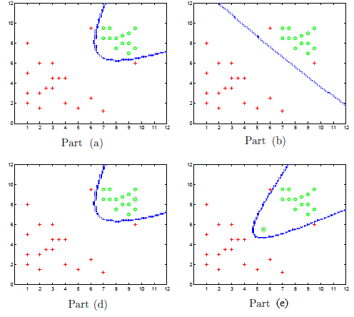

(a) Usually, MAP is less prone to overfitting than MLE. MAP introduces a prior over the parameters. So, given prior knowledge, we can bias the values of the parameters. MLE on the other hand just returns the most likely parameters. Whether MAP is really less prone to overfitting depends on which prior is used – an uninformative (uniform) prior can lead to the same behavior as MLE.
(b) NB has $1 + 2n$ parameters — prior $P(y = T)$ and for every attribute $x_{i}$, we have $p(x_{i}= T|y_{i}= T)$ and $p(x_{i}= T|y_{i}= F)$. For optimal Bayes for every configuration of attributes we need to estimate $p(y|x).$ This
means we have $2^{n}$ parameters.
(c) [5 pts] The margin will either increase or stay the same, because support vectors are the ones that hold the marging from expanding. Here is an example of increasing margin. Suppose we have one feature $x∈R$ and binary
class $y$. The dataset consists of 3 points:

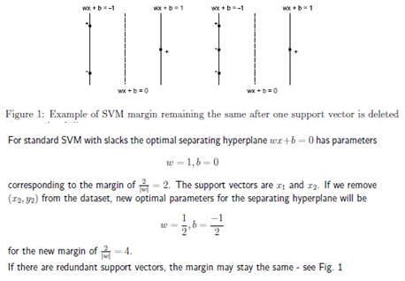
(d) False. Since a data point appears in multiple folds the training sets are dependent and thus test fold error estimates are dependent
(e) False. We do not know the relation between sample size and accuracy. High n increases correlation in training set and decreases variance of estimates. How much depends on the data and the learning method

